Country: **Togo**

Year: **2017**

Number of Observations: **4909**

Number of Clusters: **5**

Number of variables used: **23**

Distance used: **Hamming**

**Variables used in the algorithm:**

Hv206,hv207,hv208,hv210,hv211,hv227,hv243a,hv243b,hv244,hv246,hv246b,hv246g,hv246i,hv247,sh114g,sh114i,sh114m,water,toilet,floor,roof,cookfuel,wall

Excluded any binary variables with class imbalance of 7% or less

**Summary of Top Cluster Configurations (ranked by ASW)**

| **Cluster #** | **ASW** | **Variable 1** | **Variable 2** | **Variable 3** | **Variable 4** |
| --- | --- | --- | --- | --- | --- |
| **1** | 0.946136650069413 | hv206 | hv208 | sh114i | floor |
| **2** | 0.938144591273713 | hv206 | hv208 | hv243a | sh114i |
| **3** | 0.936903349358857 | hv206 | hv208 | sh114i | roof |
| **4** | 0.936735276253412 | hv206 | hv208 | sh114g | floor |
| **5** | 0.929624387964425 | hv208 | hv243a | sh114i | roof |
| **6** | 0.928726951337737 | hv206 | hv208 | hv243a | sh114g |
| **7** | 0.928036948954576 | hv206 | hv208 | sh114g | roof |
| **8** | 0.925165809680719 | hv206 | sh114i | sh114m | floor |
| **9** | 0.922501541329298 | hv208 | hv243a | sh114i | floor |
| **10** | 0.920928179814633 | hv208 | hv243a | sh114g | roof |

**Distributions of ASW values in all clusters in Togo**

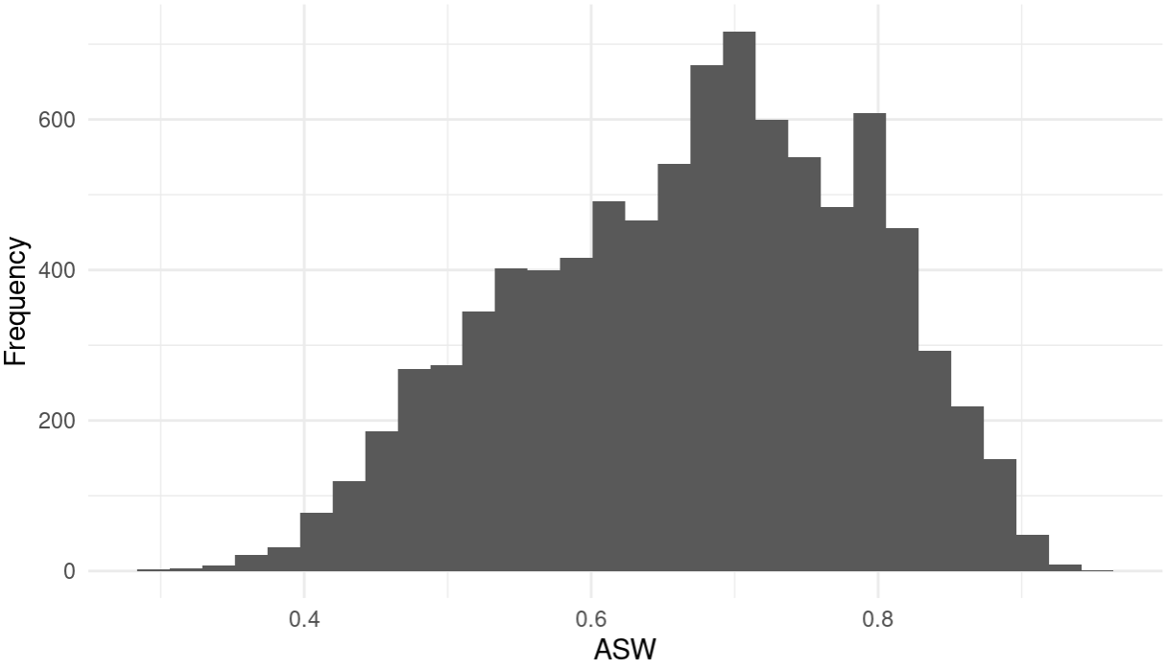

**Marginal Distributions**

| Variable | Description | % time in top clusters | Distribution |
| --- | --- | --- | --- |
| hv206 | Has electricity | 70% | Binary,44.6% 1s (or yes) |
| hv208 | Has television | 90% | Binary,30.5% 1s (or yes) |
| hv243a | Has mobile telephone | 40% | Binary,82.9% 1s (or yes) |
| sh114g | cd/dvd player | 40% | Binary,18.7% 1s (or yes) |
| sh114i | Satellite dish | 60% | Binary,12.4% 1s (or yes) |
| sh114m | fan | 10% | Binary,22.10% 1s (or yes) |
| floor | Description of floor | 40% | Categorical  0 = 15.46%  1= 0%  2 = 84.54% |
| roof | Description of roof | 40% | Categorical  Finished: 88.14%  Natural: 11.20%  Rudimentary: 0.65% |

**Summary of variable distributions in top clusters**

Currently our method is choosing five distinct clusters of individuals within each cluster variable configuration. Here are the medioids for each of these five clusters:

**Cluster #1 Configuration**

| **Config#** | **Node** | **hv206** | **hv208** | **sh114i** | **floor** | **Proportion** |
| --- | --- | --- | --- | --- | --- | --- |
| **1** | 1 | 1 | 1 | 0 | 0 | 18.9% |
| **2** | 1 | 1 | 1 | 0 | 2 |
| **3** | 2 | 0 | 0 | 0 | 0 | 13.8% |
| **4** | 2 | 0 | 1 | 0 | 0 |
| **5** | 3 | 0 | 1 | 1 | 2 | 12.4% |
| **6** | 3 | 1 | 0 | 1 | 0 |
| **7** | 3 | 1 | 0 | 1 | 2 |
| **8** | 3 | 1 | 1 | 1 | 0 |
| **9** | 3 | 1 | 1 | 1 | 2 |
| **10** | 4 | 1 | 0 | 0 | 0 | 15.6% |
| **11** | 4 | 1 | 0 | 0 | 2 |
| **12** | 5 | 0 | 0 | 0 | 2 | 41.4% |
| **13** | 5 | 0 | 1 | 0 | 2 |